PROFILE
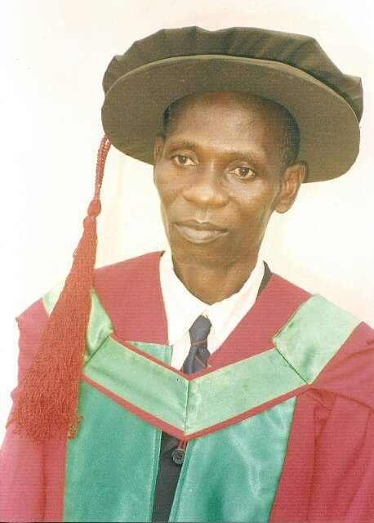

IBITOYE, STEPHEN JIMOH (PhD)
Professor of Farm Management and Production Economics
drsjibitoye@yahoo.com +2348038822144

Stephen Jimoh IBITOYE is a Professor of Farm Management and Production Economics. Prof. Ibitoye attended LGEA Primary School, Ijowa- Isanlu and also a 1975 graduate of St. Kizito’s College, Isanlu both in Kogi State, Nigeria. He holds BSc. in Agricultural Economics from the University of Ibadan (1982), PGDE from University of Jos (1985), MSc. in Agricultural Economics from University of Ilorin (1992) and PhD in Farm Management and Production Economics from University of Nigeria, Nsukka (2006).
Prof Ibitoye completed his NYSC at Bauchi State Investment and Property Development Authority from 1982 to 1983. He worked as a Lecturer at College of Education, Azare, in Bauchi State, College of Education, Oro, Kwara State, Kogi State College of Education, Ankpa and as Planning, Monitoring and Evaluation Officer at Kogi State Agricultural Development Project, Lokoja. He is currently a Professor of Farm Management and Production Economics at Prince Abubakar Audu University, Anyigba, Kogi State, Nigeria.
Prof Ibitoye has International reputation for his expertise in global Agricultural Economy. He has contributed to a number of funded research studies. He has participated as a Consultant and Trainer in many Impact Assessment Studies.
Prof Ibitoye has many publications to his credit comprising of Textbooks, Monographs, Journal Articles, Conference Proceedings and Technical Reports. His research findings have been published widely with over 70 high quality peer reviewed journal and conference publications. He has also reviewed over 50 manuscripts for both National and International journals. He is Fellows of the Institute of Corporate Administration (FCAI) and Society of Agriculture, Environmental Resource and Management (FSAEREM) and member of many International and National professional bodies. He is one of the Patrons of the Kogi Diocese of The African Church.

Prof Ibitoye served as Heads of Department at College of Education, Oro, College of Education, Ankpa and Prince Abubakar Audu University, Anyigba. He is a senate member of Prince Abubakar Audu University, Anyigba and also served in many capacities within and outside the University. In the University he has taught and supervised students at both undergraduate and postgraduate levels. He has successfully supervised over 60 undergraduates, 23 MSc and 11 PhD students and he served as external examiner for 9 MSc and PhD candidates. He served as an Adjunct Professor to the National Open University of Nigeria and Degree Programme of Kogi State College of Education, Ankpa.
Prof Ibitoye is Editor-in-Chief of International Journal of Agricultural Economics, Management and Development and also Associate Editor for International Journal of Agriculture and Veterinary Sciences. He won the prestigious 2021 Nigeria National Education Award Category of outstanding lecturer award. As a result of his outstanding contribution to Education and Community Development, he was honoured by Ijowa-Isanlu Community with Award of Excellence. He was also inducted into the Hall of Honour by Isanlu High School for his extraordinary contribution to the growth of the College. He is happily married with children.

