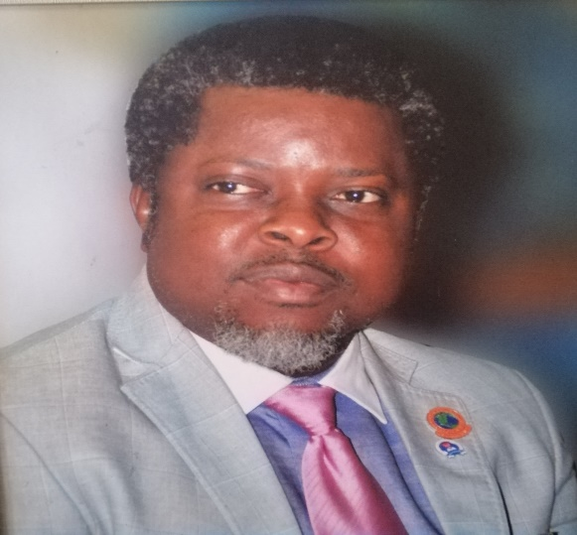

Résumé of Professor Prince Chinedu Mmom, JP

Prof. Prince Chinedu Mmom is a Professor of Environmental Management, University of Port Harcourt and holds a Doctor of Philosophy (Ph.D) Degree in Environmental Resources Planning and Management, University of Calabar, Nigeria. Prof. Mmom is a researcher and scholar listed among the first Eight Hundred (800) Scientific Researchers in Nigeria by Google Scholar, H-index and Citations, 2015 edition. He was the Director, Centre for Disaster Risk Management and Development Studies [CDRMDS], a University of Port Harcourt and National Emergency Management Agency [NEMA] collaborative initiative. Professor Mmom is currently the Dean, Faculty of Social Sciences, University of Port Harcourt (two term Dean).

He was a Research Advisor, Ogoni Restoration Project, the Shell Petroleum Development Company Limited, Port Harcourt, 2014. During his appointment, he developed additional index for measuring successful remediation of contaminated soil using vegetables as bio-indicators. He was the Acting Director of the University of Port Harcourt Campus Environmental Beautification and Sanitation Unit [CEBAS, from 2009-2013]. He is an Adjunct Scholar, Centre for Occupational Health, Safety and Environment, University of Port Harcourt, Adjunct Scholar, Institute of Petroleum Studies (IPS), University of Port Harcourt [2006-date]; Adjunct Professor, World Bank Africa Centre of Excellence in Oilfield Chemicals Research & Training (ACE-CEFOR). Professionally, Prof. Mmom is a Fellow of Nigerian Environmental Society (fmr. Chairman, Rivers State Chapter), Member, International Association for Impact Assessment (IAIA-USA) Member, International Association for Environmental Geo-technology (ISEG), Fellow, Occupational Safety & Health Association [FOSHA], Fellow, Emergency, Crisis and Risk Management Institute, Member, Association of Nigerian Geographers, Member, Association of American Geographers, Member, Nigerian Gas Association, Registered Environmental Manager with the National Registry of Environmental Professionals (NREP-USA). He is the 153rd Inaugural Lecturer of the University of Port Harcourt. He is a Member, National Technical Working Committee (NTWC) on development of the Medium Term and Long Term National Economic Development Plan and Vision 2050. 2020-date

Prof. Mmom is a Professorial Assessor/ External Examiner to many Universities in Nigeria and very special to mention, an External Assessor to the prestigious National Institute for Policy and Strategic Studies (NIPSS), Kuru-Jos. Prof. Mmom has supervised and produced over 120 Undergraduates, 42 Master’s Degree and 9 Ph.D Graduates.

Prof. Mmom is a permanent member of the Senate of the University of Port Harcourt and an Environmental Consultant with over Twenty-Five years’ experience. He hails from Omuanwa in Ikwerre Local Government Area of Rivers State. He is a Justice of the Peace (JP).

