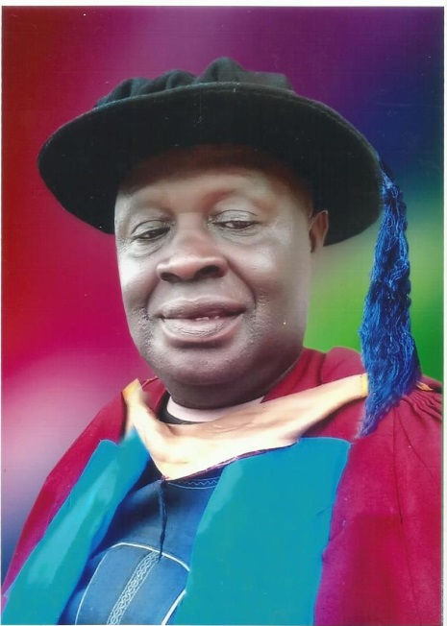

Offor, Umunagbu Stephen
Department of Agriculture,
Faculty of Vocational/Technical Education,
Ignatius AjuruUniversity of Education.
P.M.B. 5047, Port Harcourt
Rivers State.

EMAIL: Sosap2011@gmail.com&Sos2212003@yahoo.com
TEL: Mobile: +2348037766427& +234734274306

July, 2021

